Grade 2 Unit 2: Materials from the Land
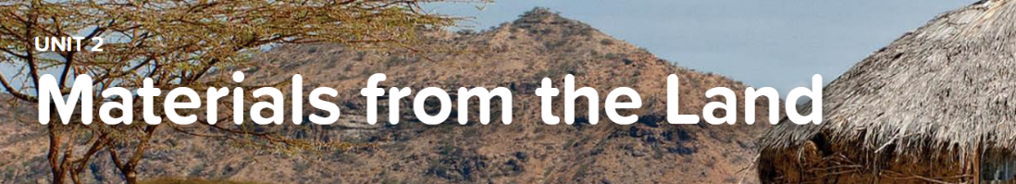

Concept 2.1 Material Properties
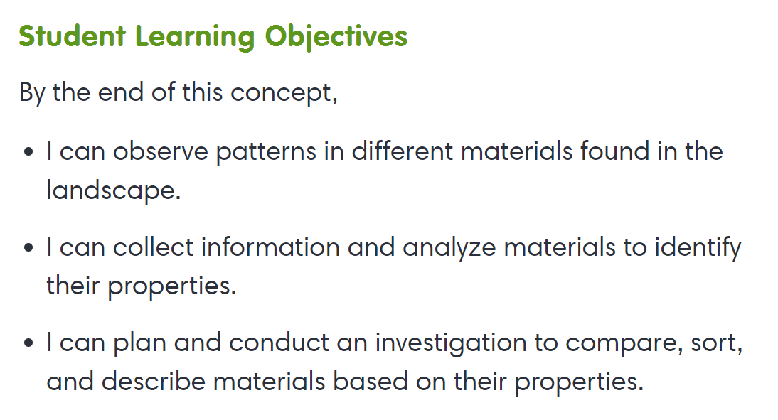
Interactive
- Mineral Resources
- Measuring Matter

Concept 2.2 Changing Materials
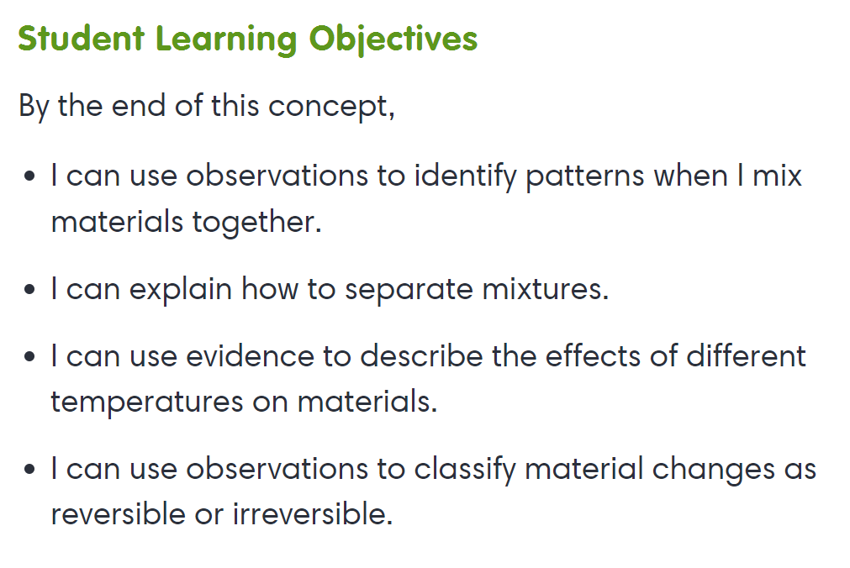
Interactive
- Things That Change

Virtual Lab
- Solutions
- Mixtures

Concept 2.3 Materials in Design
